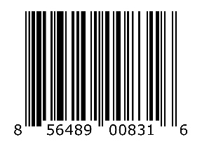
NSVFG-MLOK-AT-BLK

